**Installation/Setup procedures.**

This Add-In requires configuration and setup prior to use. This documentation is meant for an administrator who will configure and distribute the Add-In to users. The first step will be to set it up on a PC in order to configure it. Any PC will work as long as it has ArcMap 10.1 or higher on it.

At this point you have already downloaded the zip file and have unzipped it to a folder on your hard drive. We can use one of the buttons on the toolbar to help us configure the map elements for the new toolbar. Let’s create and install the toolbar.

1. Start by creating the Add-In file. To do this, navigate to where you unzipped the contents of the zip file and go into the AddIn folder.
2. Double click the makeaddin.py file to create an Add-In. You should see a file created called Ormap Map Production.esriaddin.
3. Double click this file and click Install Add-In to install into ArcMap.
4. Open your Map Production map document (mxd). In ArcMap, click Customize >> Add-In Manager. Ensure you are on the Add-Ins tab and verify that the toolbar is installed.

You can now use the Page Layout Element Report to see what map element names we currently have and compare them to what the names should be for use in the new toolbar.

1. Verify the new Ormap Map Production toolbar is turned on. In Arcmap, click Customize >> Toolbars. Scroll through the list and make sure the Ormap Map Production Toolbar has a check next to it. If it does not click it to turn it on.
2. Hover your mouse over each tool on the toolbar to find the Page Layout Element Report tool. Click this tool, specify an output for the report and press Ok.
3. When the report is finished it should open automatically. This report will contain the names and locations of the map elements on your page. These will likely need to be renamed in order for use with the new toolbar. It is recommended that you make a backup copy of your Map Production map document (mxd) prior to making these changes.

The following is a list of map elements for the new toolbar. Those denoted in bold are required. The others are optional for use in the toolbar. Your county may contain a few or all of these elements.

* **MainDF* – The main dataframe.**
* **MapNumber* – Not used on the map, however it is used by the code to determine which map you are working with.**
* MainMapTitle* – Map title.
* CountyName† – The County name.
* MainMapScale† – The map scale in the format 1” = x’
* Disclaimer* – The maps disclaimer.
* DisclaimerBox† – A box that surrounds the disclaimer.
* PlotDate* – The auto generated date on the map.
* CanMapNumber* – The cancelled numbers primary column.
* Can MapNumber2† – A second column for cancelled numbers overflow.
* CanMapNumber3† – A third column for cancelled numbers overflow.
* UpperRightMapNum* – The mapnumber listed in the upper right corner of the map.
* LowerRightMapNum* – The mapnumber listed in the lower right corner of the map.
* UpperLeftMapNum‡ – The mapnumber listed in the upper left spot.
* LowerLeftMapNum‡ – The mapnumber listed in the lower left spot.
* LocatorDF – The locator data frame.
* SectionsDF – The Sections data frame.
* QSectionsDF – The Quarter Sections data frame.
* smallMapTitle‡ – A smaller version of the MainMapTitle.
* smallMapScale‡ – A smaller version of the MainMapScale.
* NorthArrow* – The North arrow.
* ScaleBar* – The scalebar.

* These items have their x/y coordinates stored in the PageLayoutElements table.

† These items x/y coordinates derived from other page elements. These may include offsets described in the configuration files.

‡ These items x/y coordinates are not stored or calculated however the text value is repeated from another page element.

The following diagrams display the map elements as they might appear on the map. There are two examples, one for 18x20 and another for 18x24:

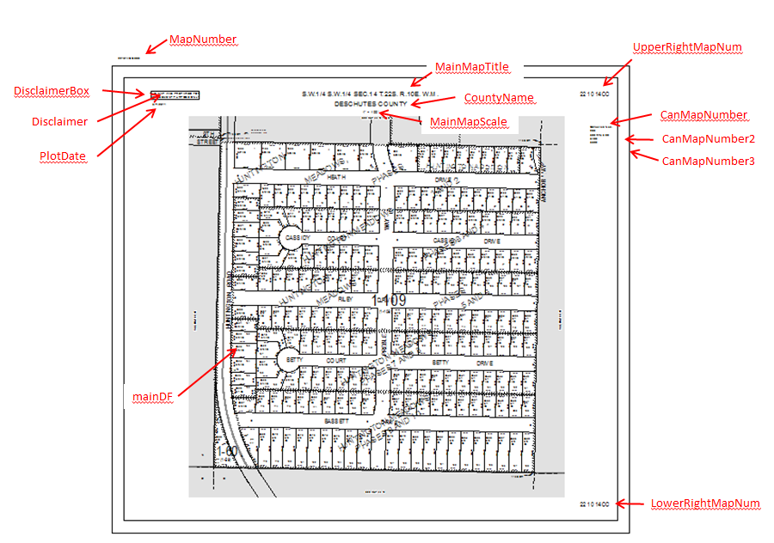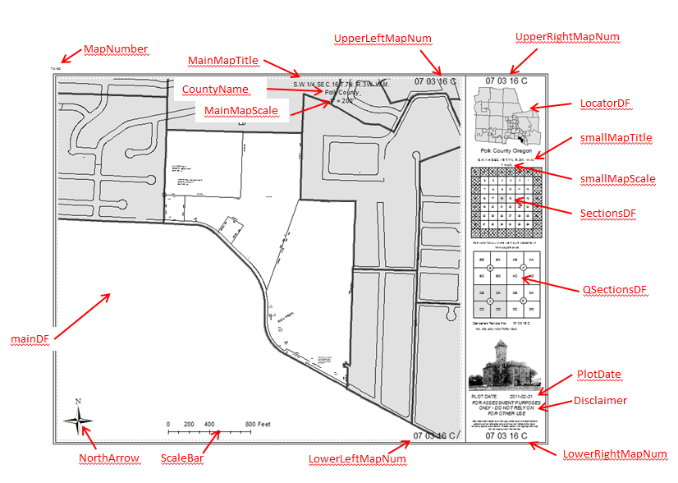

Once you have the page layout elements correctly named you are ready to create your configuration files. You likely have a MapProduction.ini file that you can use to copy/paste values from. There are now 2 configuration files instead of the old single file. One is specifically for page elements and the other is for layer properties (definition queries). These were combined into a single .ini file and are now 2 separate python files.

1. You may choose to start with a template (Deschutes Counties config files) and modify them to meet your counties requirements. To do this, navigate to where you unzipped the contents of the zip file and go into the Config File Templates folder.
2. Right click the ORMAP_LayersConfig.py and open in select Edit with IDLE (or whatever python IDE you use).
3. Open your MapProduction.ini file.
4. You will see these look very similar. There are some slight differences though. For example, the layer names in your ini file might not be surrounded by quotes, but in the new config file they are required to be. Also, in the new config file, you should leave double quotes for feature classes that you don’t use.

For example… in the ini file it currently reads:

EXTRA20_LAYER=ExtraLayer20

EXTRA20_QD=''

In the new python configuration file it should read:

EXTRA20_LAYER=""

EXTRA20_QD=""

1. Next open the MapConfig file (18x20 or 18x24) and copy/paste from your ini file.
2. For testing the config files, you can use the Import Configuration Files tool to import these updated files.
3. Check for correct map element placement with both a map that reads from the config files and one that reads from the PAGELAYOUTELEMENTS table.
4. Once you have the config files tested and working as expected you can copy them to the Add-In so that they are distributed with the Add-in. To do this, navigate to where you unzipped the contents of the zip file and go into the AddIn >> Install >> Config folder. Copy the config files here.
5. Go back to the AddIn folder and double click the makeaddin.py file to recreate the addin. The Add-In is now ready for distribution. You can email the Add-In or place it on a network share. Please read about Add-Ins on the Esri help page to learn about administering Add-Ins.